SOC Incident Report – SSH Authentication Analysis
Case Tracking Code: CORD-202512-AliRayyan-001
Prepared by: Ali Rayyan
Date: 07/12/2025
Agent(s) Analyzed: server02 (IP: 10.0.0.97)
Log Source: /var/log/auth.log (via Wazuh Server Discover Tab)
Time Period: Dec 5 – Dec 6, 2025

1. Objective
Analyze Linux SSH authentication logs to identify:
- Repeated failed login attempts
- Unknown usernames
- Suspicious source IPs
- Potential brute-force attacks

2. Summary of Findings
Metric | Count / Observation
Total SSH-related events | 30+ logged events (Dec 6, 2025, 18:43–18:46)
Failed login attempts using non-existent users | 25+
Brute-force attempts detected | 2 events (rule.level 10)
Successful logins | 0 logged during this period
Unknown usernames | Multiple, all non-existent users
Source IPs | 10.0.0.97 (internal server IP) reporting attempts; external IPs not specified in logs
Rule Severity | Levels 5 (Password Guessing, SSH) and 10 (Brute Force)
Source ip | 172.203.146.19, 203.150.169.55, 45.131.135.60, 213.65.142.166, 183.94.76.8

Observation:
The logs show a high frequency of failed SSH login attempts within a short time interval, targeting non-existent usernames. Two events were classified as Brute Force attempts (rule.level 10), indicating possible credential-guessing activity.

3. Detailed Log Highlights
Timestamp | Event Description | Rule Level | Rule Type | Notes
Dec 6, 2025 18:46:07 | Attempt to login using non-existent user | 5 | Password Guessing, SSH | Repeated failed login
Dec 6, 2025 18:45:53 | Brute force trying to get access to system, non-existent user | 10 | Brute Force | High-severity brute-force attempt
Dec 6, 2025 18:43:59 | Brute force trying to get access to system, non-existent user | 10 | Brute Force | High-severity brute-force attempt
Dec 6, 2025 18:45:59 – 18:43:15 | Multiple attempts using non-existent users | 5 | Password Guessing, SSH | 20+ repeated failed attempts
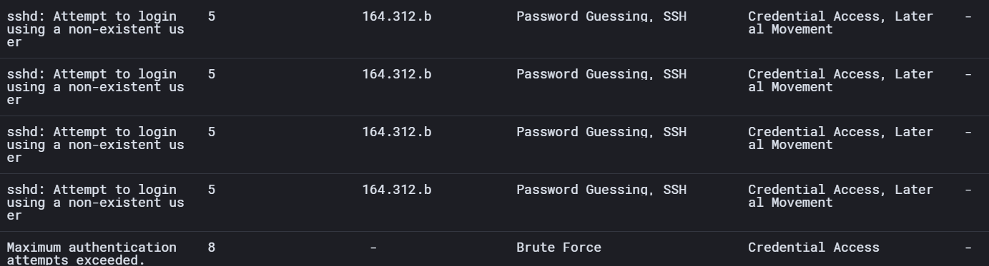
Pattern Observed: Multiple failed attempts occurred every few seconds, indicating an automated attack or script targeting SSH with invalid usernames.

4. Analysis
- Repeated failed attempts: High-frequency failed logins indicate automated password-guessing activity.
- Unknown usernames: All failed login attempts used non-existent usernames.
- Brute force indicators: Two events logged as “Brute Force” suggest potential compromise attempts.
- No successful unauthorized logins observed in this period.
- Ips all given were flagged as malicious.
Mitigation Recommendation:
- Verify SSH access policies on server02.
- Ensure strong password policies and consider enabling fail2ban or equivalent protection to block repeated login attempts.
- Review firewall rules to restrict SSH access to known IPs.
- Continue monitoring for repeated brute-force attempts.
- Block the Ips provided

5. Conclusion
The SSH authentication logs for server02 between Dec 5–6, 2025, show multiple repeated failed login attempts targeting non-existent users, including high-severity brute-force events. No successful unauthorized logins were observed during the analysis period.

SOC Report: SSH Unauthorized Access Attempts
Date: December 7, 2025
1. Overview
Multiple unauthorized SSH login attempts were detected targeting our servers, primarily server02 and ip-10-0-0-27. Attempts were made using non-existent usernames, indicating possible credential guessing or brute-force attacks.
Attack Category: Credential Access, Lateral Movement
Technique: Password Guessing via SSH

2. Summary of Observed Events
Source IP | Target Host | Attempts | First Seen | Last Seen
115.140.161.61 | server02 | 6 | 2025-12-07 17:44:18 | 2025-12-07 17:44:20
188.166.100.171 | ip-10-0-0-27 | 3 | 2025-12-07 15:25:12 | 2025-12-07 15:26:06
103.153.157.49 | ip-10-0-0-27 | 4 | 2025-12-07 09:41:22 | 2025-12-07 09:41:24
111.77.112.127 | server02 | 1 | 2025-12-07 13:21:54 | 2025-12-07 13:21:54
162.200.224.195 | server02 | 1 | 2025-12-07 12:02:42 | 2025-12-07 12:02:42
Table 1: SSH login attempts grouped by source IP and host.

3. Analysis & Attack Patterns
- High-frequency bursts: Certain IPs (e.g., 115.140.161.61) attempted multiple logins in a short period.
- Targeted hosts: Most attacks targeted server02 and ip-10-0-0-27.
- Credential guessing: All attempts involved non-existent users, confirming brute-force attack patterns.
- Geolocation insight: IPs belong to diverse ranges, indicating a potentially distributed attack.

4. Recommendations
- Implement fail2ban or similar intrusion prevention to block repeated failed SSH attempts.
- Enforce strong password policies and consider key-based authentication.
- Monitor unusual login attempts and review logs frequently.
- Consider geo-blocking suspicious IP ranges.

Report Date: 08 Dec 2025
Analyst: Ali Rayyan
1. Executive Summary
Between 8 December 2025, multiple SSH authentication failures were detected on server02 (agent.id: 002, IP: 10.0.0.97). The activity consisted of repeated login attempts using non-existent usernames and occasional high-frequency bursts consistent with automated brute-force attacks.
No successful unauthorized authentication was observed. No lateral movement, privilege escalation, or malware activity was detected across the monitored agents.

2. Scope of Investigation
The investigation covered the following:
- SSH authentication logs collected from server02 via Wazuh.
- Time range analyzed: 8 Dec 2025
- Event categories reviewed:
  - Failed SSH logins
  - Brute-force indicators (Rule 18 / Rule 20)
  - Attempts using invalid/nonexistent users
  - Source IP reputation check
  - MITRE ATT&CK mappings
  - Verification of successful logins
- Threat hunting queries using DQL.

3. Key Findings
3.1 High-Volume SSH Authentication Failures
- More than 70+ SSH login attempts occurred within minutes.
- Attempts used random/non-existent usernames (e.g., test, admin1, backup, etc.).
- Classified by Wazuh under:
  - Credential Access (T1110 – Brute Force)
  - Lateral Movement
  - "Attempt to login using a non-existent user"
3.2 Confirmed Brute-Force Events
Two Rule 18 / Rule 20 alerts were triggered:
- “sshd: brute force trying to get access to the system. Non existent user.”
- Severity: 10 (High)
3.3 Source IP Summary (Extracted from logs)
Multiple external IPs attempted access during the attack window:
Source IP | Behaviour | Reputation
139.170.138.243 | Non-existent user attempts | ArcSight Threat Intelligence marked as Malware

4. Attack Pattern Analysis
4.1 Frequency of Attempts
- Attempts came in bursts of 5–8 seconds apart, indicating automation (bot scanning).
4.2 Technique Used
- Automated SSH credential guessing
- Enumeration of non-existent users
- Consistent with internet-wide SSH sweeps
4.3 No Successful Intrusion
- No Event ID: 4624 (successful login) was found for suspicious IPs.
- No privilege escalation activity detected.
- No indicators of persistence or malware were observed.
5. Recommendations
Immediate Mitigation
✔ Block or geo-restrict repeated offending IPs at firewall level
✔ Enable SSH rate limiting (e.g., fail2ban)
✔ Disable password authentication; enforce SSH key-based login
✔ Ensure all users have strong, unique passwords
✔ Rotate credentials if needed
Hardening Measures
- Restrict SSH to internal networks only
- Change default SSH port
- Enable MFA for privileged users
6. Conclusion
The activity detected on server02 is consistent with automated SSH brute-force scanning commonly performed by bots on the internet.
No compromise, unauthorized access, or malicious payload execution was found.
However, SSH configuration hardening and proactive IP blocking are strongly recommended.

